Introduction to Decoupling navigation from course structure requirements

Purpose
This document outlines desired enhancements/additions in order to decouple navigation from course structure within Open edX. Allowing learners or course authors to 1) customize pathways as well as 2) determine learner’s pathway dynamically based on behavior and/or assessment of competency is a foundational element to adaptive/personalized learning.

Project Scope
Based on earlier research by Open edX Adaptive Learning Working Group, several use cases have been identified that demonstrate the need to decouple navigation from course structure in order to provide the following functionalities:
- a tailored course experience for expert participants based on pre-assessments to determine a) existing skills or level, b) learning objectives or c) schedule/availability
- a flexible path to navigate through course material in a non-linear way thereby allowing to a) see the overall course content, b) create custom learning paths or c) browse content in themed sequence
- a module based library (analog to chapters or fully encapsulated topic within a course) to index content by list of disciplines or skills that could be validated upon a) project completion or b) learner evaluation

References
See specific use cases from http://bit.ly/1Zb2s3N for reference:
- Use Case 1: Tailor Course Experience for Expert Participants
- Use Case 3: Flexible Paths Through Course Material
- Use Case 9: Personalized Path Through Module Library
See specific use cases from http://bit.ly/1Zb2s3N for reference:
- Presentation: https://www.dropbox.com/s/lkeyqbymaluans9/20160615_IONISx_Open_edX_Adaptive_Working_Group.pdf?dl=0https://www.dropbox.com/s/lkeyqbymaluans9/20160615_IONISx_Open_edX_Adaptive_Working_Group.pdf?dl=0
- Demo: IONISx - Courses and MiMos.pdf

Overall Description

Product Perspective
Providing Open edX with mechanisms allowing to decouple navigation from course structure while opening new possibilities to build personalized experiences for learners with flexible paths is necessarily bound to course structure design or redesign.
Currently, Open edX course structure is organized into several levels that form an outline. As such, each course outline is segmented with sections, subsections and units that contain one or more components, such as text with HTML markup, quiz questions, a discussion, or a video.
If the current course structure is well designed for course content development, it lacks the granularity necessary to customize the learner’s pathway or build it dynamically based on behavior and/or assessment of competency.

Product Functions
Developing courses is an essential aspect of pedagogical models to teach new knowledge, skills or qualifications. While the process of course development has long been a manual exercise for teachers and educational organizations, the need for tailored or personalized experiences -- taking into account a learner’s background, educational and professional objectives or progress -- requires rethinking course development design. It must become more dynamic, thereby allowing further adaptive learning processing.
- MicroModules: The basic element of any course or pathway shall be a self-sufficient MicroModule that may be tagged by discipline, skill or difficulty. Similar to an Open edX course Section, MicroModules may contain one or more Subsections but not more than a single topic in a course, or another organizing principle. While Sections in Open edX are sometimes called “lessons” that might represent a week’s worth of material, MicroModules should be much less ambitious and constrained. They should be composed of items totalling no more than 20-30 minutes worth of material. Not just 20-30 minutes of video time, but rather 20-30 minutes of summary, video, practical work, self-corrected exercises, guidance, discussion forums, etc. A MiMo should always end with an automatically corrected quiz, with which the learner can evaluate whether he or she has learned the material.
Though subject to debate, a 20-30 minute timescale has been defined as the appropriate length of a MicroModule after surveying learners. Given that 80% of them are currently employed, it is an appropriate timeframe for a subway ride, a short commuter journey, or a period of study on an in-car system. Basically, a MicroModule should be short enough to consume on the go, but long enough to grasp a pedagogical notion.
- Pathways: Pathways are essentially courses that have been developed manually or dynamically by assembling MicroModules. From a pedagogical point of view, a course author should be able to design pathways with a content structure that allows grouping pieces of courses, otherwise known as MicroModules, and additional content in sequences to form a relevant course pathway.
- Additional content: As part of a pathway structure, additional content may be included prior to or after individual MicroModules to enhance the user experience and organize the learner’s journey. Examples of additional content may include: chapters, notes, exams, milestones, certificates, etc… that may lock/unlock access to subsequent pathway content or trigger changes in the learner pathway.
- MicroModule-based libraries: With MicroModules as the basic elements of any course or pathway, MicroModule-based libraries may be generated to index content by list of disciplines, skills or levels. Furthermore, these MicroModule-based libraries may be reorganized dynamically if triggered by an event such as a project completion or learner evaluation .
Building and running an edX Course is at the core of Open edX development platform. While the current architecture provides a sophisticated outline tailored for most organisations running MOOCs, revisiting course structure is essential for decoupling navigation to provide tailored course experience with flexible paths, thereby meeting adaptive learning working group objectives.

Pedagogical setup of a pathway / course
Composition of the pathway / course:
Below is an example of a pedagogical model or educational program that determines the learning progress otherwise know as a pathway. This pathway is structured using a set of MicroModules, each providing individual pieces of learning material (text, video, quiz, etc). Additional content such as exams or evaluations may be added along the track to continually assess and adapt the pathway to the learner's progress. An acquired skillset of competencies may reward the learner with a form of recognition (certificates, badges, percentage of completion of the program, etc).

Skills Matrix of the pathway / course:
Skills and competencies are an essential part of pathway / course design: they enable assessment of a learner’s progress. In order to tailor pathway composition to a learner’s level or achievements, skills metrics shall be added to each MicroModule setting. As a result, individual MicroModules may be dynamically added, removed or accounted for in a learner’s pathway. Another example would be to initially assess a learner’s knowledge or skillset and subsequently adapt the learner’s pathway. Also, this would permit the assessment of exactly which modules should be studied, and the construction of custom pathways to obtain certain qualifications or skillsets.

Milestones of the pathway / course:
Assessing knowledge and setting milestones along a learner’s track is a key part of evaluating a learner’s progress. Milestones may be achieved by successfully completing MicroModules’ self-contained evaluations or by taking individual assessments as part of an additional content within a pathway.

Back Office setup of a pathway / course
Pathway / Course settings and basic info:
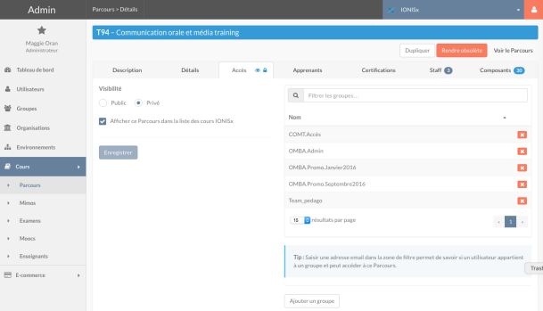

Composition of the pathway / course:
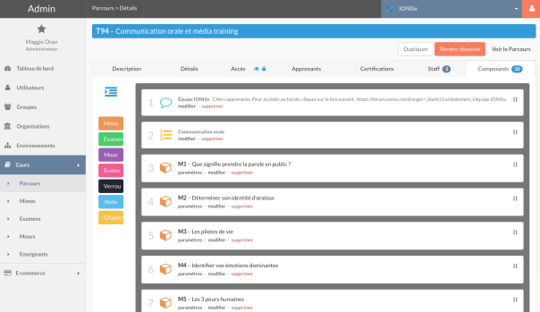

Back Office setup of a MicroModule (MiMo)
MicroModule settings and basic info:
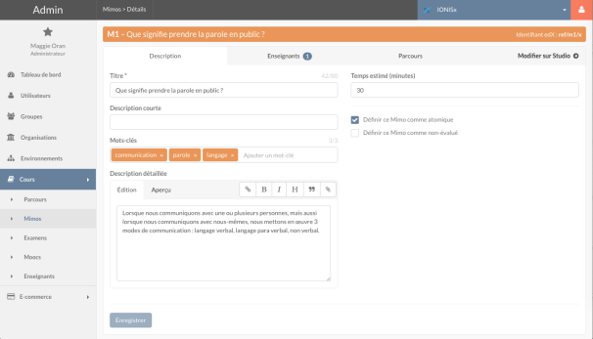

Pathways / Courses in which a MicroModule is included:
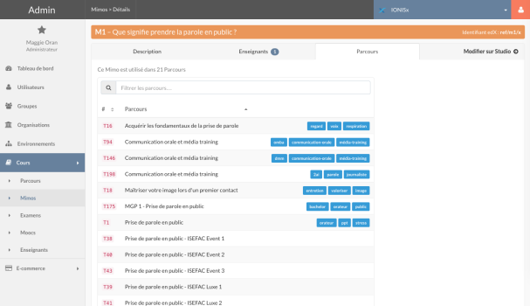

What the learner sees
Learner’s view of the pathway / course material:
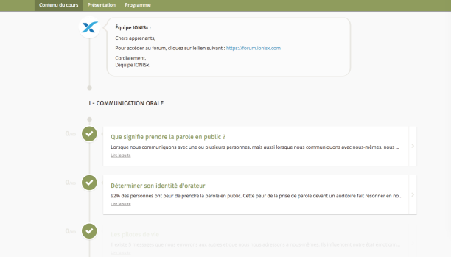

Learner’s view of the MicroModule:
Example of a MicroModule that represents a single topic in a course (structured as a single course/section with several subsections, each of which has a single unit) with components that may be consumed in no more than 20-30 minutes.
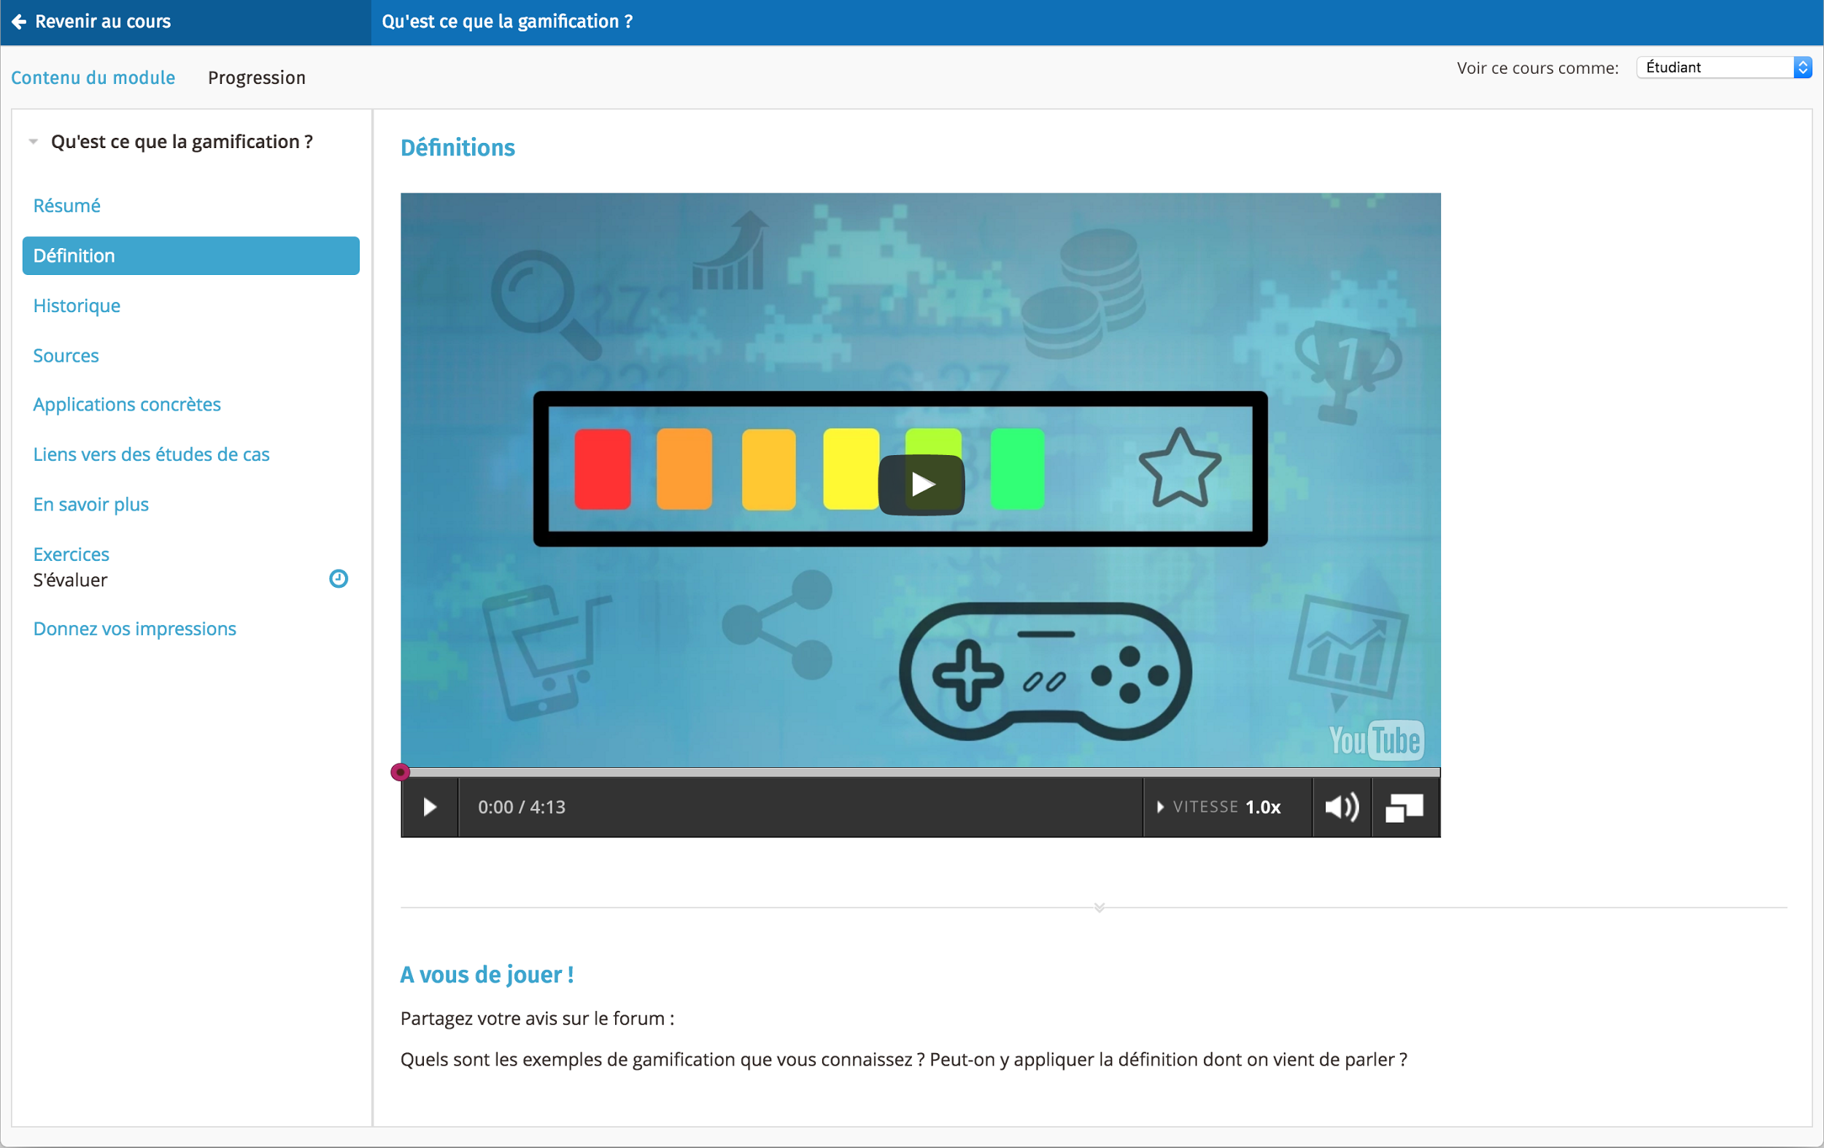

Operating Environment
TBD

Design and Implementation Constraints
TBD

User Documentation
TBD

Assumptions and Dependencies
TBD

External Interface Requirements

User Interfaces
TBD

Hardware Interfaces
TBD

Software Interfaces
TBD

Communications Interfaces
TBD

System Features

TBD

Other Nonfunctional Requirements

Performance Requirements
TBD

Security Requirements
TBD

Software Quality Attributes
TBD

Business Rules
TBD

Other Requirements
TBD

Appendix A: Glossary
TBD

Appendix B: Analysis Models
TBD

